Investigate Patterns: Contrasting non-European locality
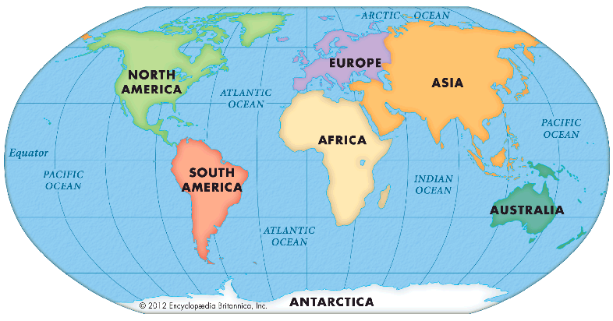
In Geography, we will be learning to:
locate hot and cold areas of the world
name and locate continents and oceans
find locations on a map
discuss how climate affects human geography
create a map
explore similarities and differences between the UK and a non-European country
explore a small area of a non-European country
understand reasons for migration
discuss the impact of tourism
Key Questions:
Why are some places hot and some cold?
How does Kenya compare and contrast with England?
How are people in Kenya affected by their climate and tourism?

